# Software Requirements Specification

# for

# OTT Platform

Version 1.3 approved

Prepared by AYUSH DEV

CSE TMSL

15-11-2023

Table of Contents

1. Introduction 4

1.1. Purpose 4

1.2. Scope 4

1.3. Definitions, Acronyms, and Document Conventions 4

1.4. References 5

2. History/Background Study 5

2.1. Existing Applications 5

2.2. Customer Surveys 5

3. The Overall Description 7

3.1. Product Functions 7

3.1.1. Hardware Requirements 7

3.1.2. Software Requirements 7

3.2. Functional Requirements 7

3.2.1. User Registration and Authentication 7

3.2.1.1. Creating New Account (Sign Up): 7

3.2.1.2. Log-In: 7

3.2.1.3. Forgot Password: 7

3.2.2. Users 8

3.2.2.1. Search Shows 8

3.2.2.2. Content Browsing 8

3.2.2.3. Resolve Query 8

3.2.2.4. Watch Trailer 8

3.2.2.5. Offline Downloads 8

3.2.2.6. Manage Subscription & Payment 8

3.2.2.7. Overview & Rating 9

3.2.2.8. Create Watchlist 9

3.2.2.9. Rate & Review 9

3.2.2.10. Content Recommendation 9

3.3. Non-Functional Requirements 9

3.3.1. Performance Requirements 9

3.3.2. Security Requirements 9

3.3.3. Reliability Requirements 9

3.3.4. Scalability Requirements 10

3.3.5. Compatibility Requirements 10

3.4. User Characteristics 10

3.4.1. Free Users 10

3.4.2. Subscribed Users 10

3.4.3. Guest Users 10

3.5. Design & Implementation Constraints 10

3.6. Assumptions & Dependencies 11

4. Interface Requirements 11

4.1. User Interfaces 11

4.2. Hardware Interfaces 11

4.3. Software Interfaces 12

4.4. Communication Interfaces 12

5. Conclusion 12

# Introduction

An OTT platform (Over-The-Top platform) is a digital streaming service that delivers video content, audio, and other media directly to users over the internet.

The platform aims to provide seamless access to a variety of content user-friendly streaming experience. multi device support. personalize recommendations. It will provide flexibility in terms of subscription plans, allowing users to choose the content they want to watch and pay for specific services, unlike traditional cable packages.

## Purpose

The purpose of this Software Requirements Specification (SRS) for an OTT (Over-The-Top) platform is to serve as a comprehensive and structured document that outlines the functional and non-functional requirements, constraints, and expectations for the development and implementation of the platform.

This document is intended for the following:

* Developers for the purpose of maintenance and new releases of the software.
* Describe the complete behavior of the application proposed.
* The final goal is to produce a stable and high-quality SRS.

## Scope

With the rise of multiple OTT platforms, each offering exclusive content, users often face the challenge of subscribing to multiple platforms. It is costly and inconvenient to manage subscriptions required to access their favorite content.

The platform's scope encompasses providing digital streaming services for video, audio, and text-based content accessible through web browsers, mobile apps, and smart TV applications. It includes features for user registration and authentication, content management, content discovery, streaming and playback, user profiles, personalization, subscription and monetization systems, and user interaction elements.

## Definitions, Acronyms, and Document Conventions

* OTT (Over-The-Top) Platform: An online streaming service delivering video, audio, or text content via the internet.
* Adaptive Streaming: Real-time quality adjustment based on user internet and device.
* Personalization: Tailoring content and features to user preferences.
* Subscription Model: Charging users for premium content access.
* Admin Dashboard: Back-end for content and user management.
* UI (User Interface): The graphical layout and elements that users interact with in software applications.
* UX (User Experience): The overall quality of a user's interaction with a product or service.
* API (Application Programming Interface): A set of rules enabling different software components to communicate and interact.

## References

* <https://www.academia.edu/>
* <https://www.studocu.com/>
* <https://www.coursehero.com/>
* <https://chat.openai.com/>
* <https://www.netflix.com/in/>

# History/Background Study

## Existing Applications

* Netflix: A global streaming service that offers a vast library of movies, TV shows, and original content.
* Amazon Prime Video: Part of Amazon Prime, it provides a wide range of video content, including original series and movies.
* Hulu: Offers a variety of on-demand streaming content, including current TV episodes and original shows.
* Disney+: Disney's platform featuring content from Disney, Pixar, Marvel, Star Wars, and National Geographic.
* Apple TV+: Apple's streaming service featuring original content and shows.

## Customer Surveys

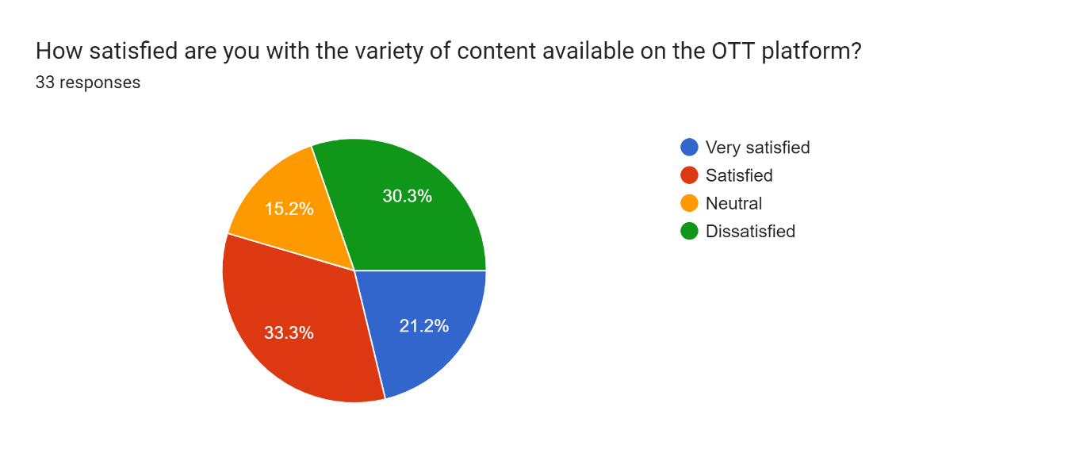

Forms response chart. Question title: How satisfied are you with the customer support and help center provided by the platform?
. Number of responses: 33 responses.

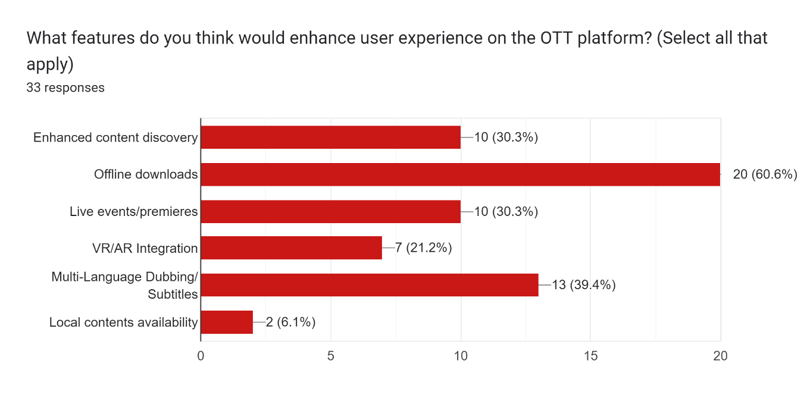

Forms response chart. Question title: What factors influenced your decision to choose a OTT platform over others? (Select all that apply)
. Number of responses: 33 responses.

# The Overall Description

## Product Functions

### Hardware Requirements

The major hardware requirements of the system are described as follows:

* Hard Disk Space: At least 250 MB of free storage space with 2 GB RAM is necessary for the system's installation and data storage.
* Android: Minimum processor specification of Snapdragon 600 series.
* Windows: At least an 8th generation Intel Core i3 processor.
* iOS: A device with at least an Apple A11 Bionic processor.

### Software Requirements

* A database management system like MySQL is required for storing and managing system data.
* A modern web browser such as Chrome, Mozilla Firefox, or any equivalent is needed for accessing the system's web interface.
* Windows: At least Windows 7 64-bit or higher.
* Mac: macOS 10.11 or later.
* Android: At least Android Oreo (version 8).
* iOS: At least iOS 11 or later.

## Functional Requirements

### User Registration and Authentication

#### Creating New Account (Sign Up):

* **Description:** New users should be able to register in the platform.
* **Input:** The user needs to give the following inputs:

○ Login Name ○ Password ○ Confirm Password ○ Email

* **Output:** A new account is created and a confirmation mail is sent to the registered email.

#### Log-In:

* **Description:** Existing users should be able to login to the platform using their credentials.
* **Input:** The existing user must input the following:

○ Email ID

○ Password

* **Output:** The user gains access to their personalized account.

#### Forgot Password:

* **Description**: The platform provides an option to retrieve the profile.
* **Input**: Enter the registered Email ID.
* **Output**: A verification link is sent to the registered e-mail to reset the password to a new one.

### Users

#### Search Shows

* **Description:** User is presented with the choice to browse content by entering name.
* **Input:** User types any keyword in the search box.
* **Output:** The platform provides the related content according to the search.

#### Content Browsing

* **Description:** Users can sort content based on their choice of genre.
* **Input:** Select any genre to view content.
* **Output:** Shows of the particular genre.

#### **Resolve Query**

* **Description:** Users can contact the website admin in case of any query or doubt.
* **Input:** Enter the query related to the website or content.
* **Output:** The query is sent to the admin and a ticket is generated.

#### Watch Trailer

* **Description:** The platform provides the option to watch the trailer of the show.
* **Input:** Click on the watch trailer button of any particular show.
* **Output:** The page is redirected to the trailer of that show.

#### Offline Downloads

* **Description:** Premium users can download shows to watch online.
* **Input:** Click on the download button.
* **Output:** The media gets downloaded in the app.

#### **Manage Subscription & Payment**

* **Description:** Users can choose the subscription model of their choice or choose to cancel one.
* **Input:** Go to the premium tab and select plan.
* **Output:** The page is redirected to the payment gateway.

#### Overview & Rating

* **Description:** One can view the basic details about the show like the plot, IMDB rating and duration.
* **Input:** Click on the know more option or hover over the show poster.
* **Output:** The details are shown.

#### **Create Watchlist**

* **Description:** User can create a watchlist of their choice.
* **Input:** Click to add the show to your playlist or watchlist.
* **Output:** The selected content is added to the list.

#### **Rate & Review**

* **Description:** The user can rate and review the movie of their choice.
* **Input:** Enter a review of the show.
* **Output:** The review is reflected to other users.

#### Content Recommendation

* **Description:** The user will get personalized recommendation according to their watch/search history.
* **Input:** Go to the ‘for you’ section.
* **Output:** Personalized content library is shown.

## Non-Functional Requirements

### Performance Requirements

* The platform should load content and respond to user interactions quickly, providing a seamless and responsive experience.
* It should aim to minimize buffering and ensure smooth playback during streaming.
  + 1. Security Requirements
* User data should be encrypted and stored securely to protect against unauthorized access and data breaches.
* The platform should implement secure authentication mechanisms to prevent account breaches.

### Reliability Requirements

* The platform should have high availability and be operational most of the time to ensure a consistent user experience.
* It should minimize downtime for maintenance and updates.

### Scalability Requirements

* The platform should be designed to handle a large number of users without compromising performance.
* It should be efficient to accommodate a growing user base and increased traffic.

### Compatibility Requirements

* The platform should be compatible with a wide range of devices, browsers, and operating systems to reach a broader audience.
* It should support popular video and audio formats for seamless playback.

## User Characteristics

The Online Social Networking System will cater to the following user classes:

### Free Users

* Free users are individuals who have registered but are not subscribed to premium services.
* They can access a limited selection of content, primarily consisting of free or ad-supported content.
* Free users may experience advertisements while using the platform.

### Subscribed Users

* These are individuals who have registered and subscribed to the platform's services.
* Subscribed users can access the full range of features, including streaming content, creating playlists, and interacting with other users.
* They have access to premium and personalized content based on their subscription plan.

### Guest Users

* Guest users are individuals who visit the platform without registration.
* They have limited access to public content, such as previews, trailers, and publicly available information.
* Guest users are not able to access premium content or personalized features.

## Design & Implementation Constraints

* The platform will utilize modern web development frameworks, streaming technologies, and content delivery solutions to ensure a seamless and efficient user experience.
* Data privacy regulations and best practices will be adhered to.
* The user interface and user experience design will prioritize intuitiveness and accessibility, ensuring that users can easily navigate and interact with the content.
* The system's design should be modular and scalable to allow for easy expansion of features in the future.
* The user interface (UI) and user experience (UX) design should follow best practices to ensure ease of use and navigation for users.
* The system should be developed with secure coding practices to prevent common vulnerabilities, such as SQL injection and cross-site scripting (XSS) attacks.

## Assumptions & Dependencies

The successful development and operation of the OTT Platform are based on the following assumptions and dependencies:

* **Internet Connectivity:** Users require reliable internet access for streaming content.
* **Content Licensing:** The platform depends on content licensing agreements.
* **Content Delivery:** It relies on third-party Content Delivery Networks for efficient content delivery.
* **User Devices:** Users must have compatible devices for content access.
* **Payment Processing:** Payment processing services are used for subscription management.

# Interface Requirements

## User Interfaces

* The user interfaces should be designed with a responsive layout, adapting to different screen sizes.
* The design should be intuitive, visually appealing, and consistent throughout the application.
* The system will integrate with social media platforms (e.g., Facebook, Google) for seamless user authentication and sign-up.
* APIs from content-sharing platforms (e.g., Twitter) may be utilized to enable users to easily share their favorite content or recommendations with their social networks, enhancing user engagement and content promotion.

## Hardware Interfaces

* The system shall securely store user data, including user profiles, preferences, viewing history, and account information, to provide personalized experiences.
* User passwords shall be securely hashed and stored.
* User viewing history and content preferences shall be stored to support content recommendation and personalization features.

## Software Interfaces

* The system shall prioritize fast response times for all user interactions, including loading content pages, streaming videos, accessing content, and engaging with features, to enhance the user experience.
* The average response time for critical operations should be within milliseconds.

## Communication Interfaces

* The system shall provide a user-friendly error handling mechanism that communicates clear error messages to users.
* The system shall have a backup and disaster recovery plan to safeguard user data.
* The system shall comply with relevant data protection and privacy laws, such as GDPR or CCPA.
* The system shall implement age restrictions and obtain parental consent for users under the legal age of consent.

# Conclusion

In summary, this Software Requirements Specification (SRS) provides a detailed blueprint for the development of an Over-The-Top (OTT) platform. The document outlines the platform's purpose, scope, features, and technical specifications. The OTT platform's primary goal is to offer a user-friendly and immersive digital streaming experience, allowing users to access a diverse range of multimedia content seamlessly. Users can personalize their profiles, engage with peers, share content, and participate in various community activities.

The SRS places a strong emphasis on security, scalability, performance, and accessibility, ensuring a responsive and secure platform. Modern web technologies, robust authentication methods, and real-time features are key components to provide a seamless user experience.

By adhering to the guidelines outlined in this SRS, the development team can efficiently create a secure and feature-rich OTT platform that aligns with user expectations and industry standards. Continuous testing, iterative enhancements, and compliance with legal and regulatory requirements will contribute to the platform's long-term success and competitiveness in the digital content streaming landscape.